Ideation Phase
Define the Problem Statements
Date | 14 October 2026
Team ID
Project Name | Automated Network Request Management System
Maximum Marks | 2 Marks

Customer Problem Statement Template:
Create a problem statement to understand your customer's point of view. The Customer Problem Statement template helps you focus on what matters to create experiences people will love.
A well-articulated customer problem statement allows you and your team to find the ideal solution for the challenges your customers face. Throughout the process, you’ll also be able to empathize with your customers, which helps you better understand how they perceive your product or service.
Reference: https://miro.com/templates/customer-problem-statement/
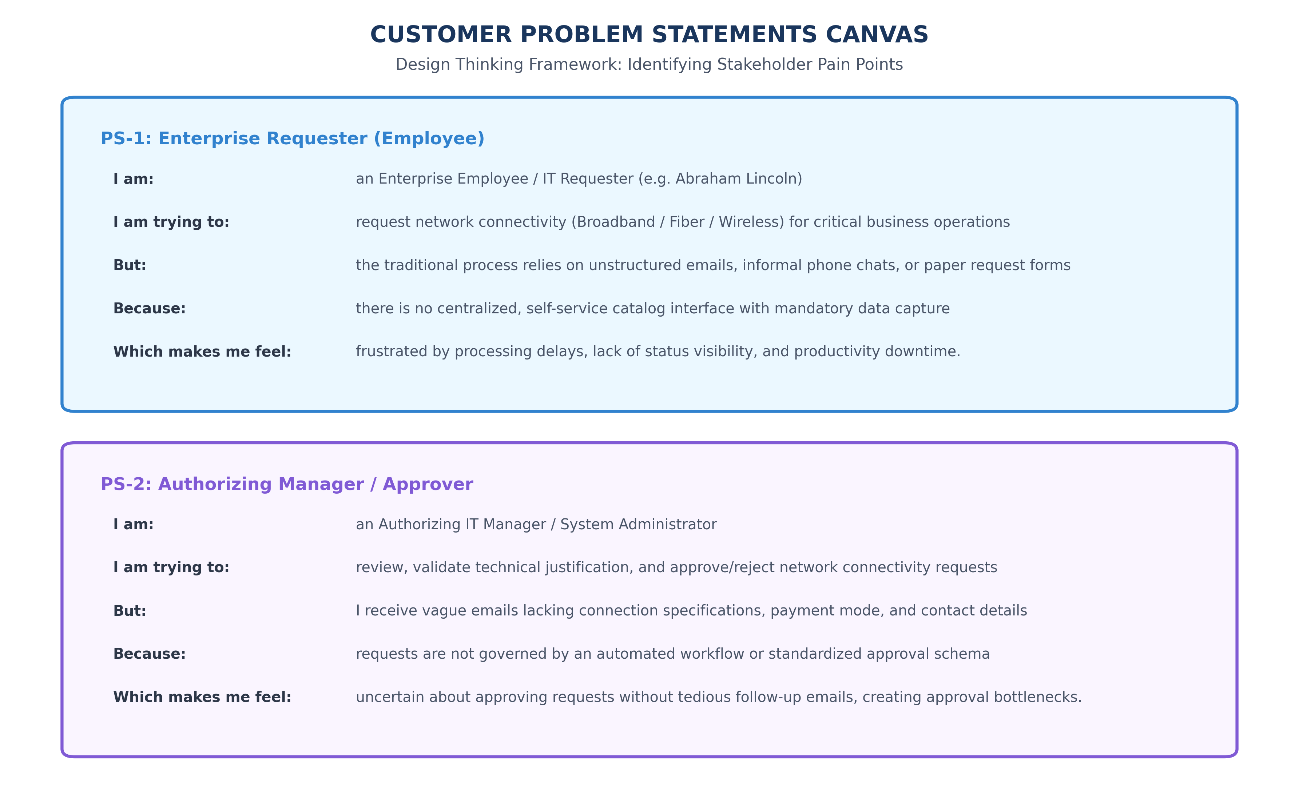
Figure 1.3: Customer Problem Statement Visual Canvas
Problem Statement (PS) | I am (Customer) | I’m trying to | But | Because | Which makes me feel
PS-1 | Enterprise Requester (Abraham Lincoln) | Request network connectivity (Broadband/Fiber/Wireless) | Requests sent via informal emails or paper forms | No centralized self-service catalog with validation | Frustrated by delays and lack of tracking.
PS-2 | Authorizing IT Manager | Review and authorize network requests promptly | Emails lack connection specs, amount, or address context | No automated workflow routing or approval schema | Uncertain about approving unvetted expenses.
PS-3 | Network ITIL Engineer | Fulfill physical wiring and network activation within SLA | Requests arrive with missing address or wrong contact | Manual data entry lacks validation and task generation | Overwhelmed by rework and missed SLAs.

